Task 1 — Data Cleaning
Import the Movies dataset into Power BI.
Students must perform these transformations in Power Query:
- Check and correct the data types.
- Convert Release_Date to Date.
- Convert Budget, Box_Office, Rating, Votes and Runtime_Minutes to appropriate numeric types.
- Remove duplicate Movie_ID records.
- Remove rows where Movie_Name is blank.
- Replace blank OTT_Platform values with "Not Available".
- Trim unnecessary spaces from Movie_Name.
- Clean the Genre column.
- Rename Box_Office to Box_Office_Collection.
- Sort movies by Release_Date.
Task 2 — Power Query Derived Column
Create a new column:
Movie_Year
Requirement:
Extract the year from Release_Date.
Task 3 — Power Query Conditional Column
Create:
Rating_Category
Rules:
- Rating >= 8 → "Excellent"
- Rating >= 7 → "Good"
- Rating < 7 → "Average"

3. Calculated Columns — DAX
Create two calculated columns.
Calculated Column 1
Create:
Profit
Business requirement:
Calculate the movie profit using Budget and Box Office Collection.

Calculated Column 2
Create:
Profit_Percentage
Business requirement:
Calculate the profit percentage based on Budget and Profit.
Do not provide the DAX formula to students.

4. DAX Measures
Students must create the following measures.
Measure 1 — Total Box Office
Requirement:
Calculate the total box-office collection of all movies.
Function to use:
SUM()

Measure 2 — Average Rating
Requirement:
Calculate the average movie rating.
Function to use:
AVERAGE()

Measure 3 — Movie Count
Requirement:
Calculate the total number of movies.

Measure 4 — Average Box Office
Requirement:
Calculate the average box-office collection per movie.

Measure 5 — Movie Rank
Requirement:
Rank movies based on Box Office Collection.
Function to use:
RANKX()
Expected behavior:
When Movie Name is placed in a visual, each movie should display its rank.

Measure 6 — Genre Rank
Requirement:
Rank movie genres based on total box-office collection.
Use:
RANKX()

Measure 7 — Total Box Office ignoring Genre Filter
Requirement:
Create a measure that:
Calculates total box-office collection while ignoring the current Genre filter.
Function to use:
ALL()

Measure 8 — Genre Percentage
Requirement:
Calculate the percentage of total box-office collection contributed by each genre.
Students should use:
- CALCULATE()
- ALL()

Measure 9 — Action Movie Box Office
Requirement:
Calculate the total box-office collection only for Action movies.
Students must use:
CALCULATE()

5. KPI Cards
Create the following KPI/card visuals:
KPI 1
Total Movies
KPI 2
Total Box Office
KPI 3
Average Rating
KPI 4
Total Profit
Students should format the cards appropriately.

6. Line Chart
Create a Line Chart.
Requirement
Show:
Movie Year → Total Box Office
- X-axis → Movie Year
- Y-axis → Total Box Office
Students should be able to identify how movie collections changed over the years.

7. Clustered Bar Chart
Create a Clustered Bar Chart.
Requirement
Show:
Genre → Total Box Office
Students should:
- Display Genre on the axis.
- Display Total Box Office as the value.
- Sort from highest to lowest.
- Add an appropriate title.
Additional challenge
Apply a Top 5 visual filter to show only the five genres with the highest box-office collection.

8. Pie Chart
Create a Pie Chart.
Requirement
Show:
Genre distribution by number of movies
- Legend → Genre
- Values → Movie Count
Students should format the percentage/data labels.

9. Visual-Level Filter
On the Movie/Genre bar chart:
Display only movies/genres where Total Box Office is greater than a specified value.
Students should understand the difference between:
- Visual-level filter
- Page-level filter
- Report-level filter

10. Slicers
Add the following slicers:
Slicer 1
Genre
Slicer 2
Language
Slicer 3
Movie Year
Slicer 4
OTT Platform
Students should test whether the visuals respond to the slicers.

11. Visual Interaction
Task
Configure interactions between the visuals.
For example:
When the user selects a Genre in the pie chart:
- KPI cards should update.
- Line chart should update.
- Bar chart should update.
Then change one interaction so that a particular visual does not respond to the selection.
Students should demonstrate:
Filter interaction vs No interaction.

12. Movie Details Table
Create a table containing:
- Movie Name
- Genre
- Language
- Release Date
- Rating
- Budget
- Box Office
- Profit
- Profit Percentage
- Movie Rank
Apply conditional formatting to:
- Rating
- Profit
- Profit Percentage

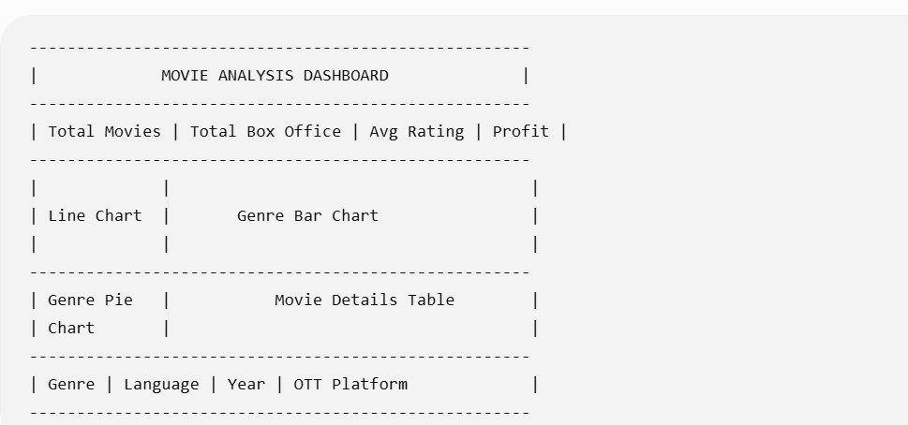
Challenge 1
Find the total box-office collection.
Challenge 2
Find the average movie rating.
Challenge 3
Find the highest box-office collection.
Challenge 4
Rank movies according to box-office collection.
Challenge 5
Find the percentage contribution of each genre to overall box-office collection.
Challenge 6
Show total box-office collection for Action movies only.
Challenge 7
Create a measure that ignores the Genre filter.
Challenge 8
Show only the Top 5 genres based on box-office collection.

Student Submission Checklist
Students should submit a .pbix file containing:
- Power Query transformations
- Movie Year column
- Rating Category column
- Profit calculated column
- Profit Percentage calculated column
- Total Box Office measure
- Average Rating measure
- Movie Count measure
- Movie Rank using RANKX
- CALCULATE measure
- ALL measure
- KPI cards
- Line chart
- Clustered bar chart
- Pie chart
- Visual-level filter
- Four slicers
- Visual interactions
- Movie details table
- Conditional formatting

